C.M.SAJID(192411162)
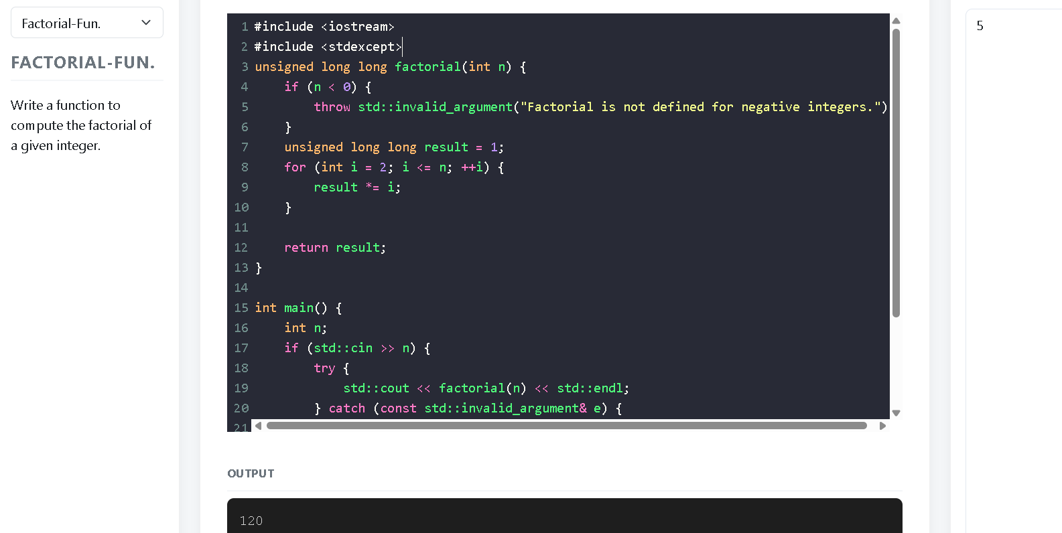
1.FACTORIAL FUNCTION
2.PRIME FUNCTION

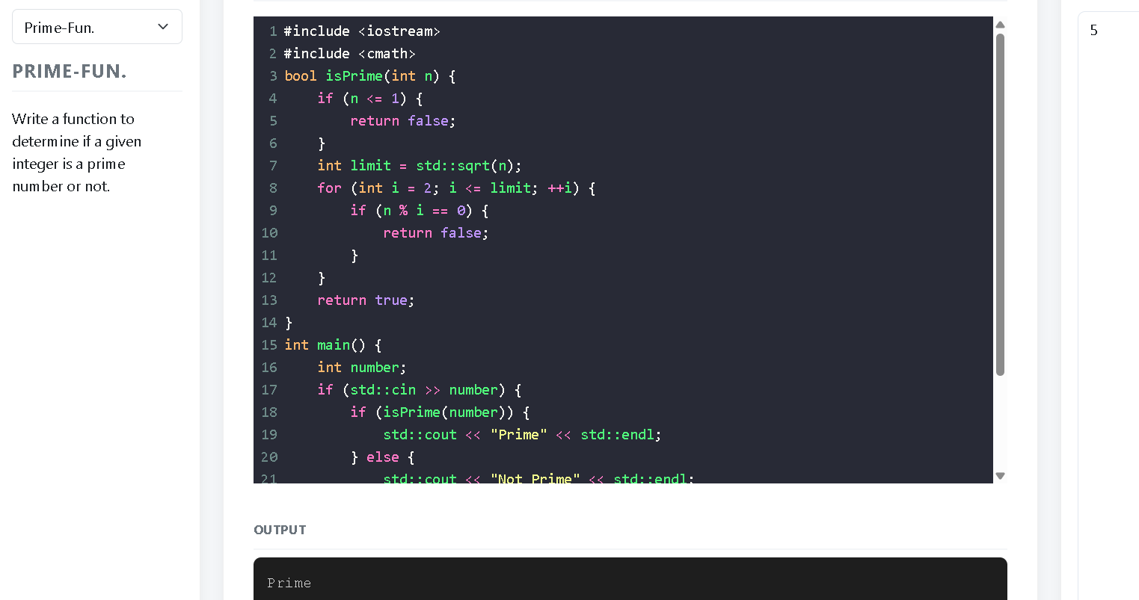

C.M.SAJID(192411162)

3.GCD FUNCTION
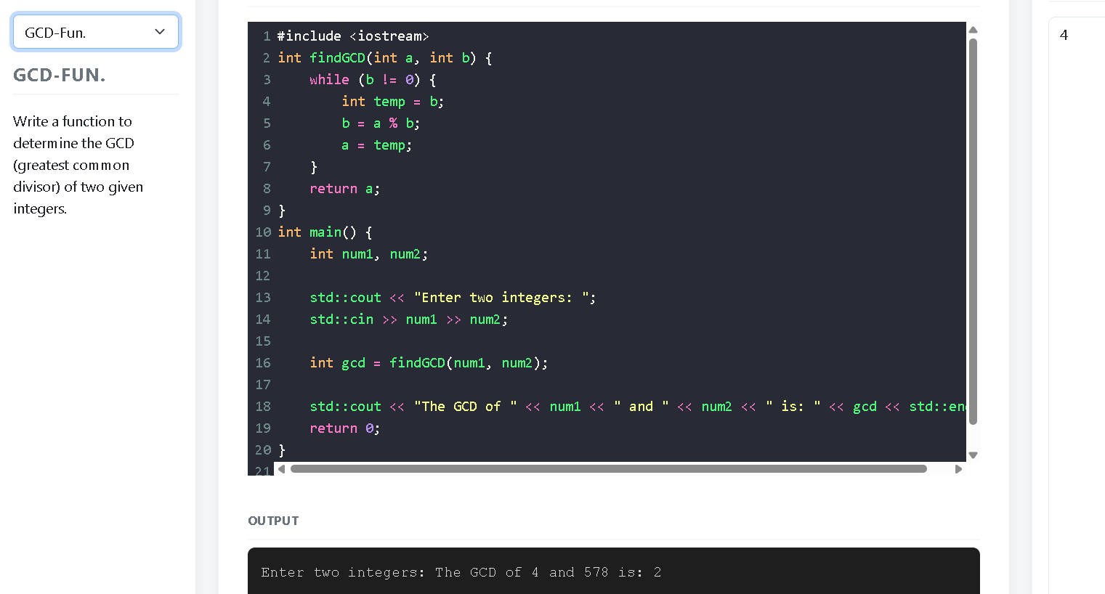
4.PALINDROME FUNCTION
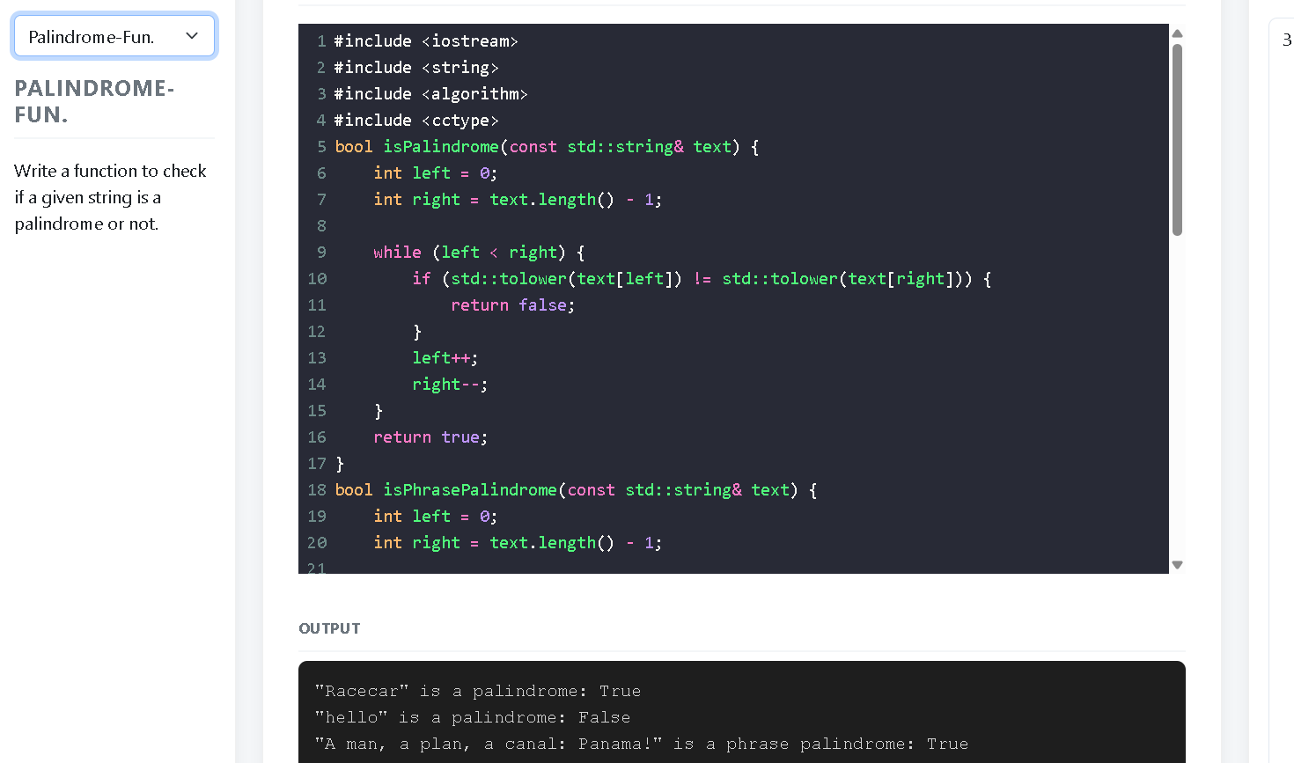

5.AREA
